­­­­­­­­­­­

|  |  |
| --- | --- |
| **Ex. No: 7** | **Routing Implementation using ExpressJS** |
| **28.09.2023** |

**Aim:**ToImplement the routing feature(s) using the ExpressJS.

**Algorithm:**

1. Include the required header files thread creation and sleep() function.
2. Write a function that executes as a thread when it is called. (sleep – print - return)
3. thread_id is declared to identify the thread in the system, we call pthread_create() function to create a thread.
4. The pthread_join() function for threads is the equivalent of wait() for processes. A call to pthread_join blocks the calling thread until the thread with identifier equal to the first argument terminates.

**Program:**

const express = require('express');

const bodyParser = require('body-parser');

const app = express();

const port = 3000; // You can change this to any port you prefer

app.set('view engine', 'ejs'); // Use EJS as the template engine

app.use(bodyParser.urlencoded({ extended: false }));

app.use(express.static(__dirname + '/public'));

const posts = []; // Simulated database for storing blog posts

// Home page route

app.get('/', (req, res) => {

res.render('home', { posts });

});

// New post form route

app.get('/newpost', (req, res) => {

res.render('newpost');

});

// Create a new post route

app.post('/create', (req, res) => {

const { title, content } = req.body;

const newPost = { title, content };

posts.push(newPost);

res.redirect('/');

});

// JSON API endpoint to fetch all posts

app.get('/api/posts', (req, res) => {

res.json(posts);

});

// Start the server

app.listen(port, () => {

console.log(`Server is running on port ${port}`);

});

**Output:**

Github Link: <https://github.com/kavin-t28/CS3809-Web-Technologies-Lab>

1. Initial webpage when the server is started.

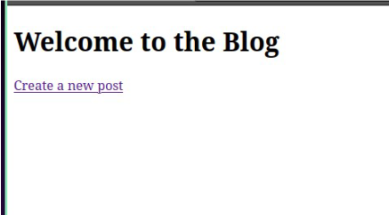

1. New blog creation page

1. When we create new blogs the title of the blog gets updated in the home page

1. All the blog content for that session can be assesed in the /api/posts route in json formate

**Result:**

Therefore, we've successfully implemented a basic routing implementation using Express JS